# Select workspace:

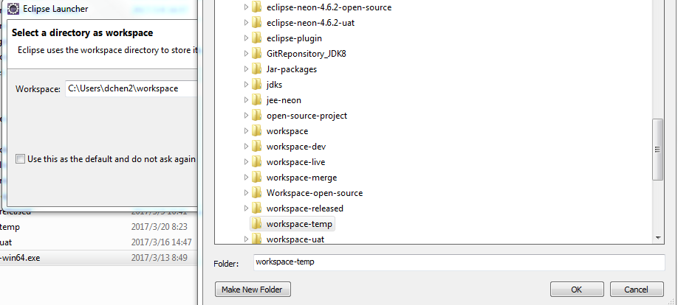

# Configure Maven:

Window->preferences->Maven

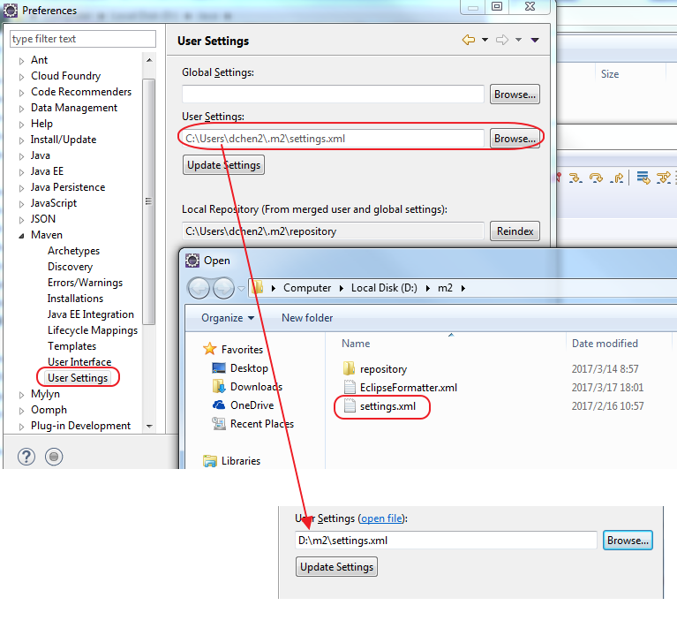

# Configure Git:

Window->preferences->Team->Git

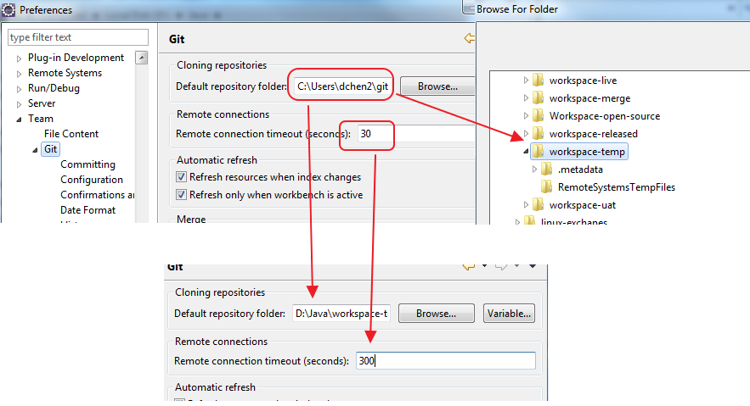

# Encode:

Window->preferences->General->Workspace

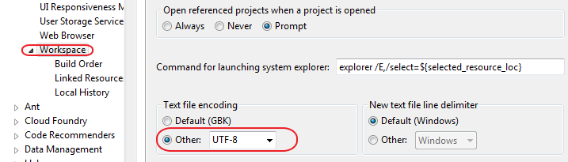

# Configure comparation:

Window->preferences->General->Compare/Patch

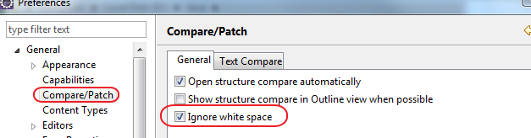

# Insert spaces for tabs:

* Window->preferences->General->Editors->Text Editors

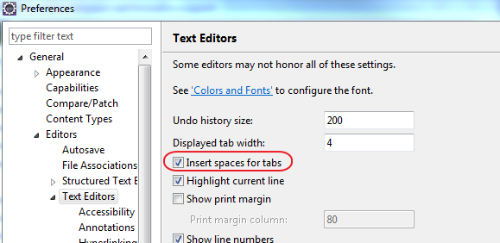

* Window->preferences->Java->Code Style->Formatter

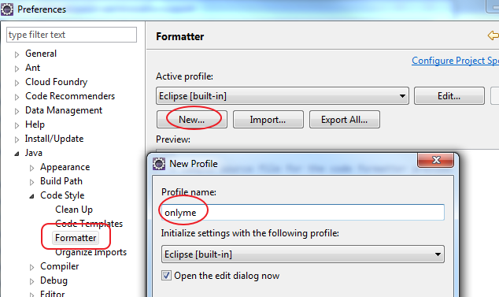

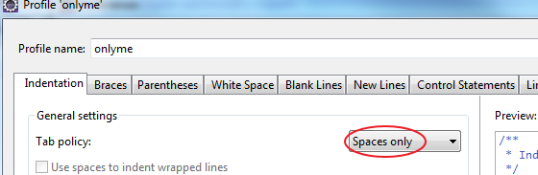

# Other settings:

Window->preferences->Java->Editor->Typing

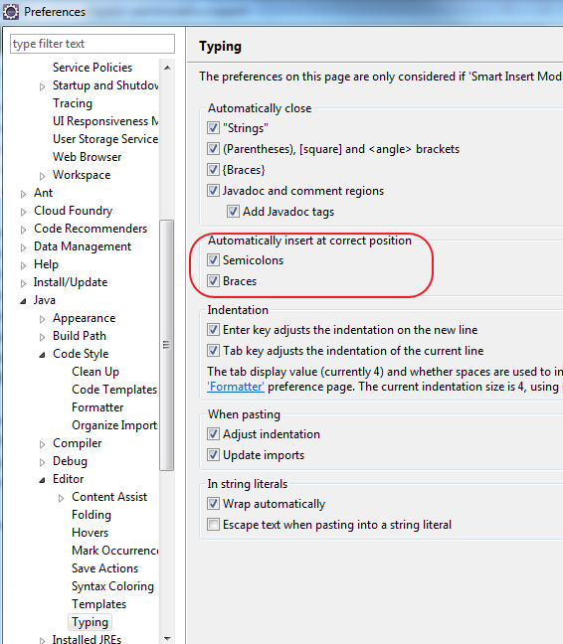

Window->preferences->Java->Editor->Save Actions:

